**DOKUMENTASI PROJEK HCI LAB**

**REFERENSI GAMBAR**

**Testimonial:**

https://images.pexels.com/photos/6135782/pexels-photo-6135782.jpeg?

https://images.pexels.com/photos/6382477/pexels-photo-6382477.jpeg?

**CATALOG:**

https://id.pinterest.com/arianatorlover1/aesthetic-bp/

https://newsmaker.tribunnews.com/2020/11/18/populer-member-bts-jadi-cover-majalah-legendaris-amerika-milik-v-paling-laku-terjual-segini

**ALBUM:**

https://id.pinterest.com/pin/162270392813122411/

https://wallpapers-hub.art/group/bts#image-1606

https://wallpapercave.com/search?q=itzy

**Merchandise**

https://id.pinterest.com/pin/702350504369284732/

https://id.pinterest.com/pin/845691636265830689/

https://br.pinterest.com/pin/590534569885193083/

**Blackpink Album**

<https://i.pinimg.com/originals/6d/99/67/6d9967456acac60b7dd0c62b11b306a1.png>

<https://id.pinterest.com/pin/415808978101656113/>

<https://id.pinterest.com/pin/473722454554790287/>

https://id.pinterest.com/pin/208361920249557631/

**BTS ALBUM**

https://wallpaperaccess.com/love-yourself-tear-bts

https://wallpaperaccess.com/map-of-soul-7-bts

https://wallpaperaccess.com/bts-wings-desktop

https://wallpaper.dog/bts-dark-and-wild-wallpapers

**ITZY ALBUM**

<https://id.pinterest.com/pin/349451252345445614/>

<https://id.pinterest.com/pin/590041988676964022/>

<https://id.pinterest.com/pin/692709986436355040/>

<https://id.pinterest.com/pin/593349319638020706/>

**BTSMERCH**

https://id.pinterest.com/pin/613334042995766347/

https://id.pinterest.com/pin/667447607269942591/

https://id.pinterest.com/pin/790241065872130268/

https://id.pinterest.com/pin/357332551690875178/

**BLACKPINK MERCH**

https://id.pinterest.com/pin/302867143698603951/

https://id.pinterest.com/pin/784893041311538236/

https://id.pinterest.com/pin/777082110699433250/

https://id.pinterest.com/pin/180003316365339653/

**ITZYMERCH**

https://id.pinterest.com/pin/653796070901375888/

https://id.pinterest.com/pin/679621400019026395/

https://id.pinterest.com/pin/636696466064642932/

https://id.pinterest.com/pin/679621400019026196/

https://id.pinterest.com/pin/66357794498121308/

**Menu icon**

<https://www.flaticon.com/free-icon/menu_1828859?term=menu&page=1&position=2&page=1&position=2&related_id=1828859&origin=tag> (in media screen=600px and dropdown)

**SCREENSHOT PAGE**

**Menu Homepage**

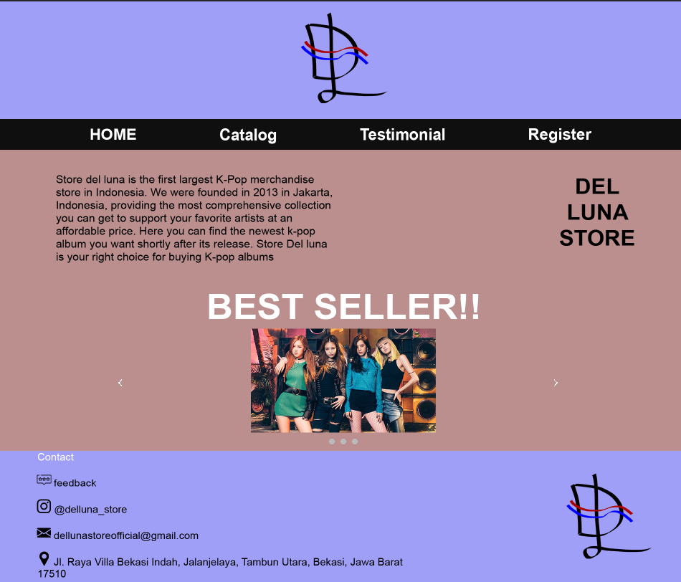

**Menu register**

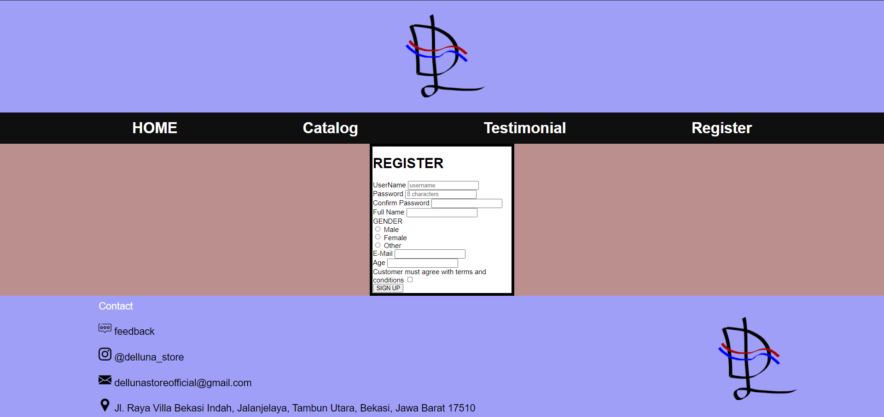

**Menu Testimonial**

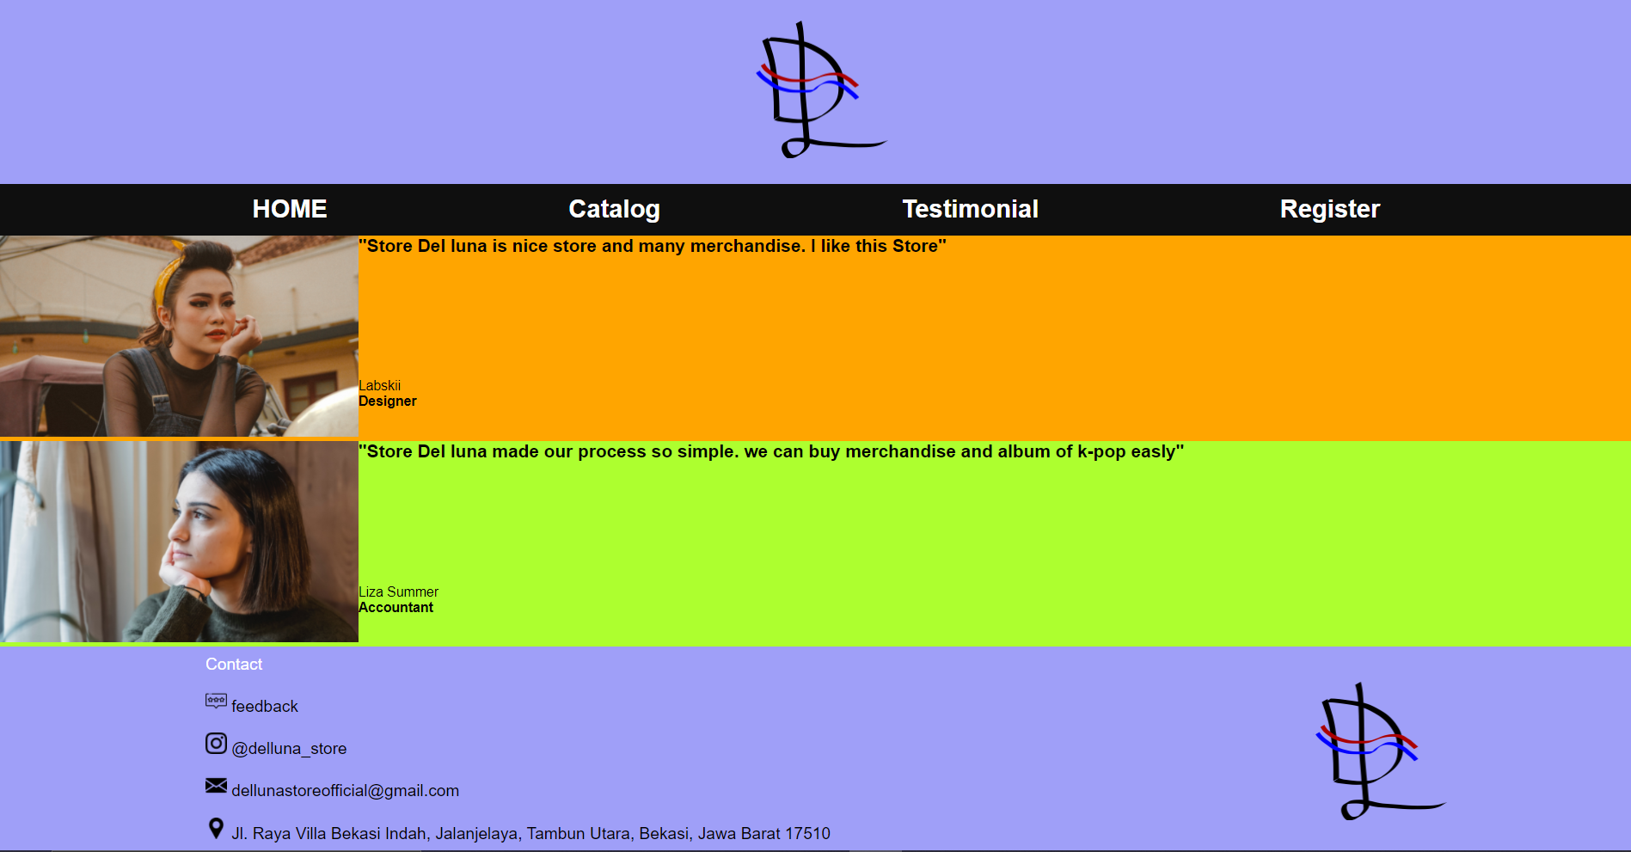

**Menu Catalog**

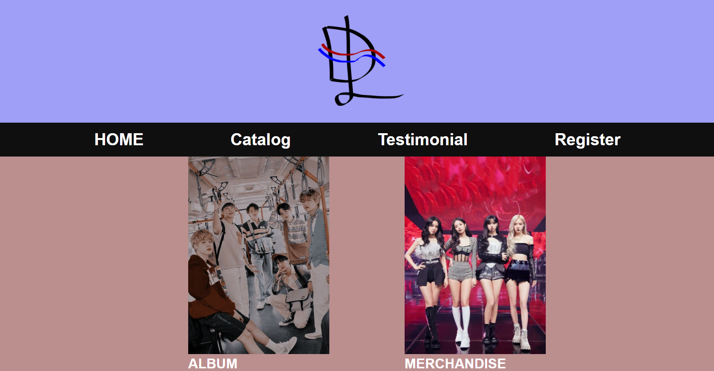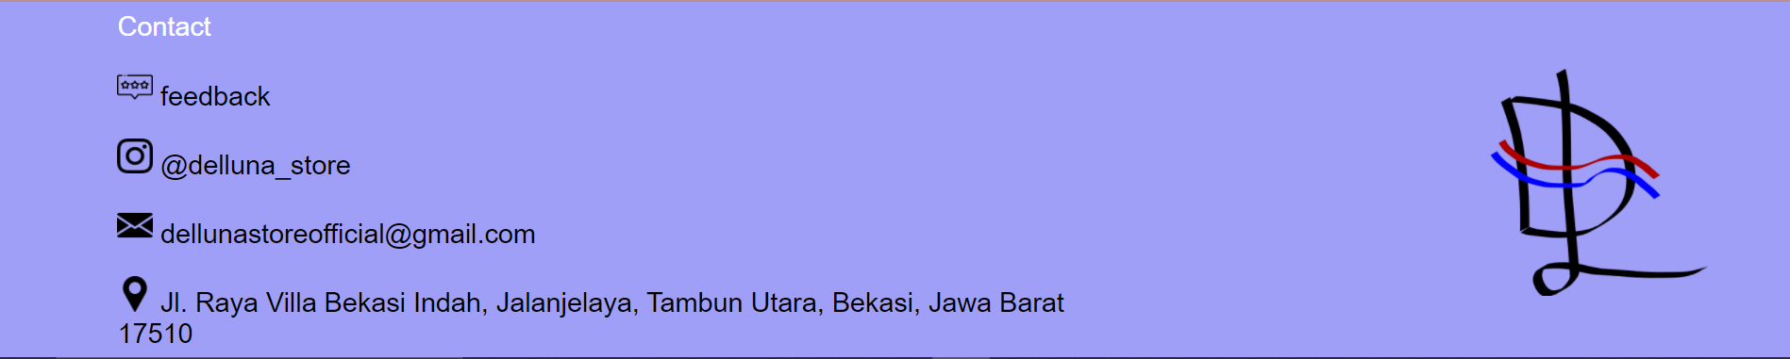

**Menu Album**

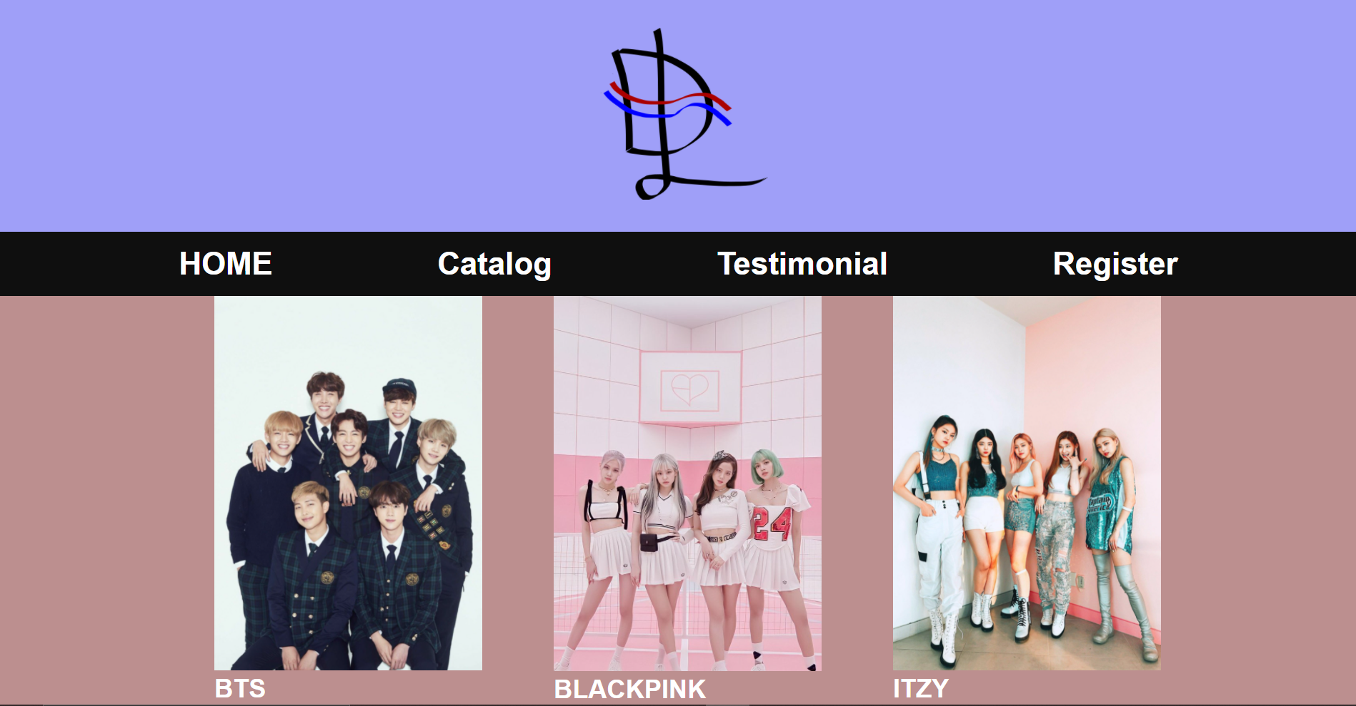

**Menu Merchandise**

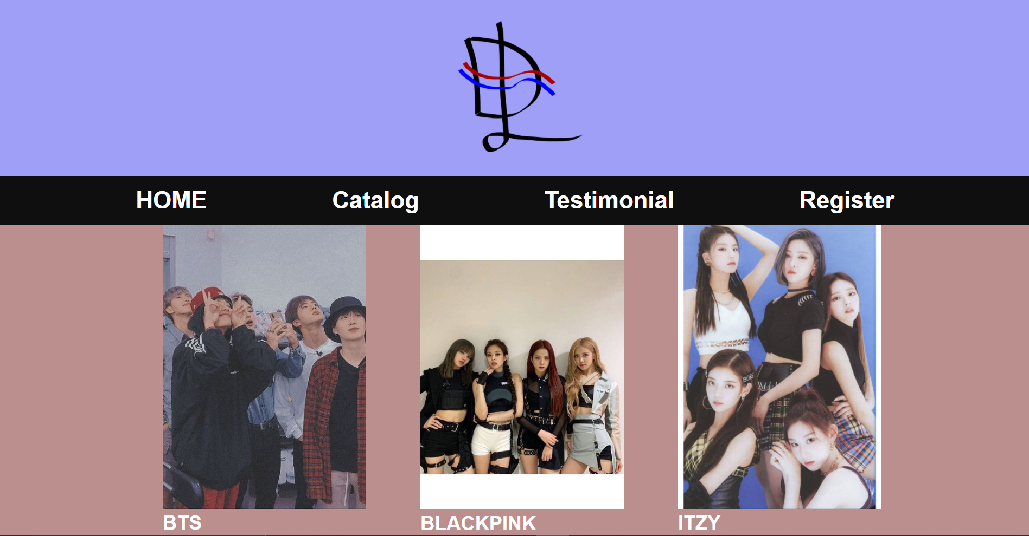

**Menu Merchandise BTS**

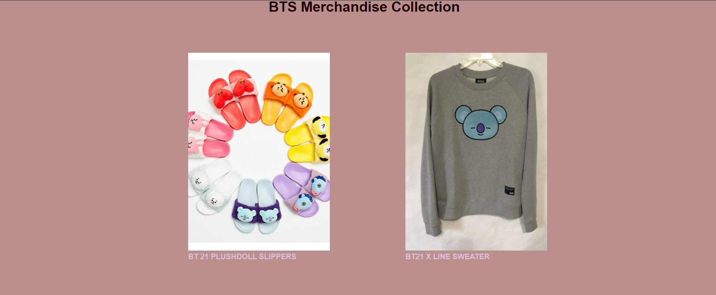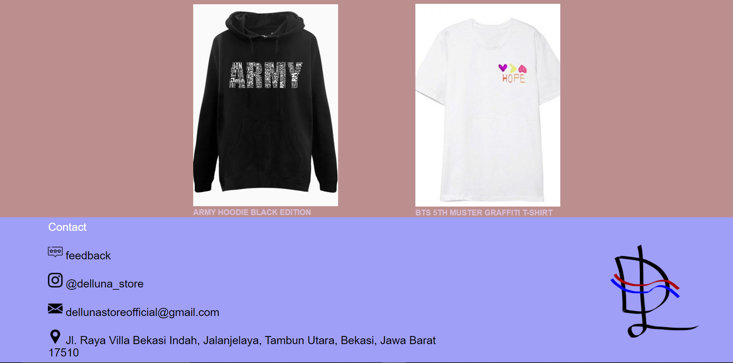

**Menu merchandise Blackpink**

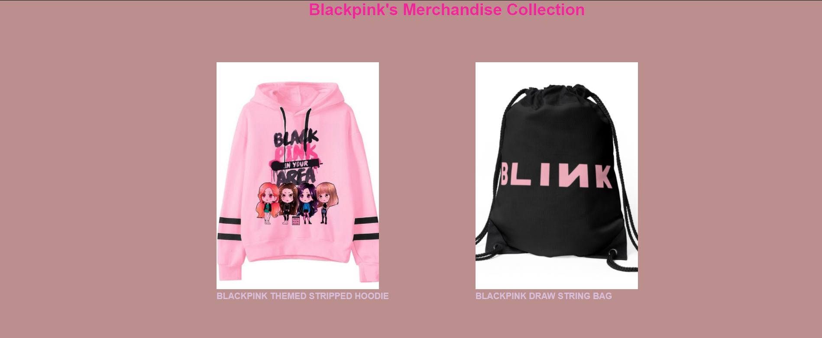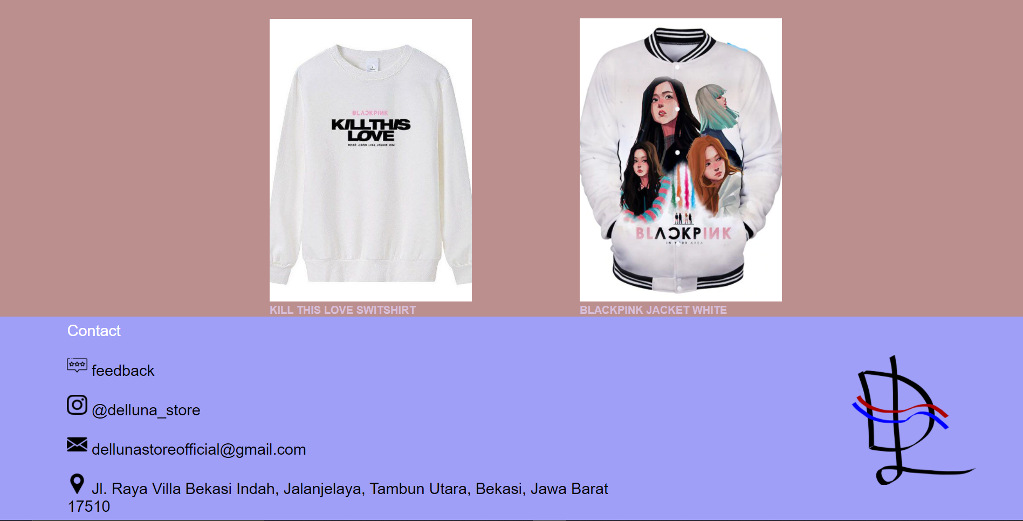

**Menu merchandise ITZY**

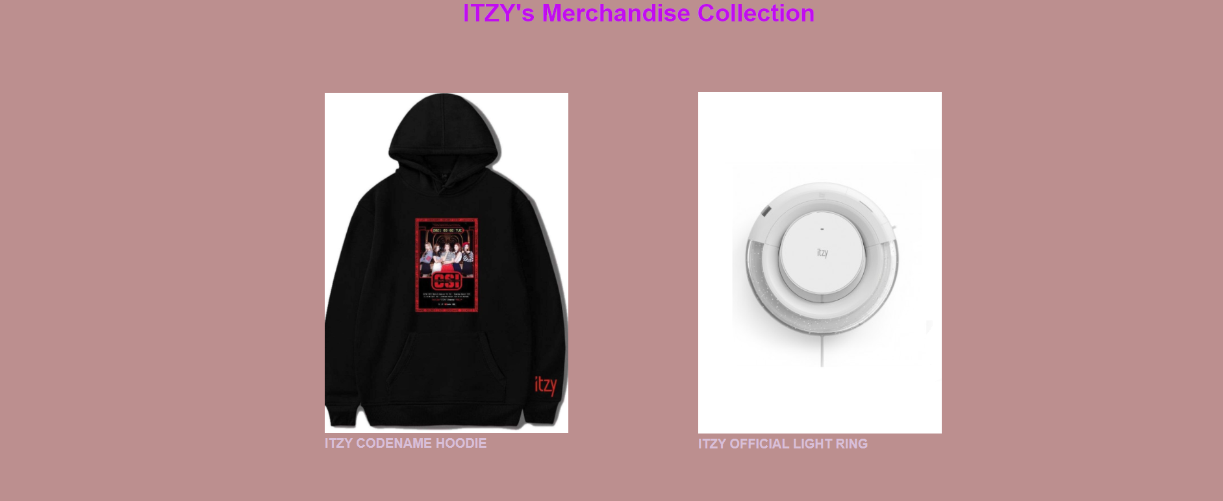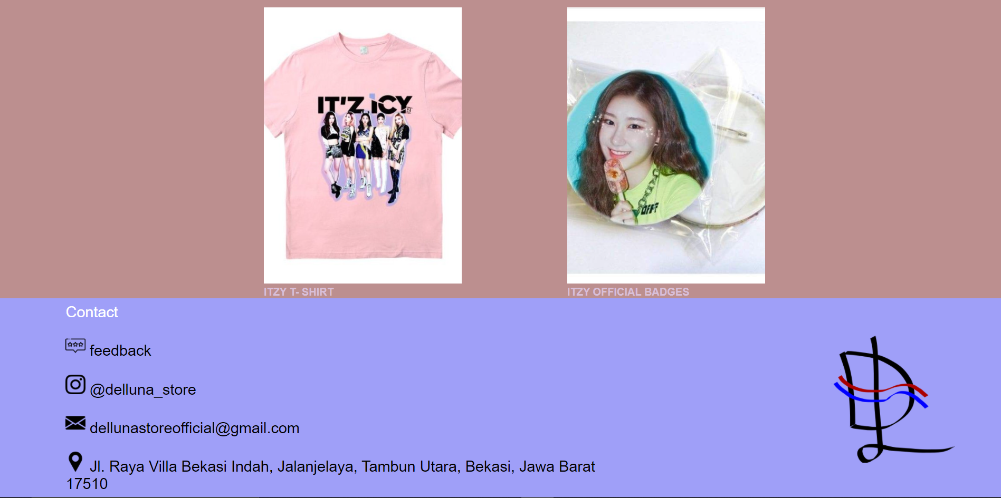

**Menu Album BTS**

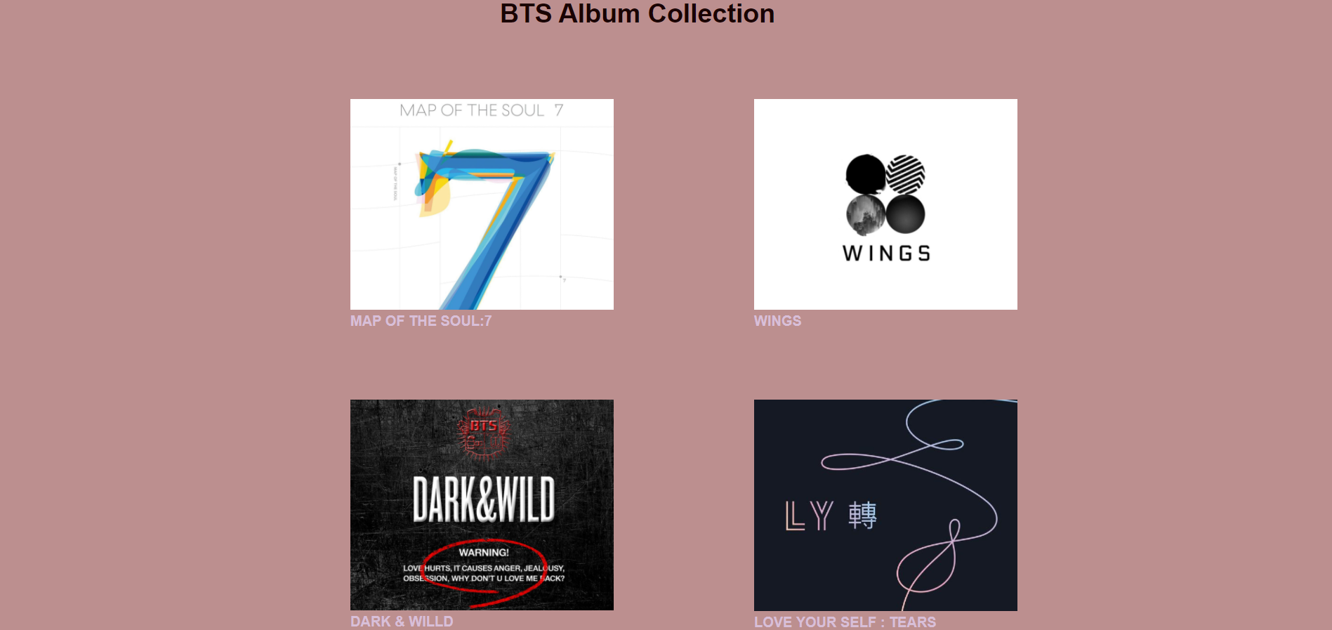

**Menu album Blackpink**

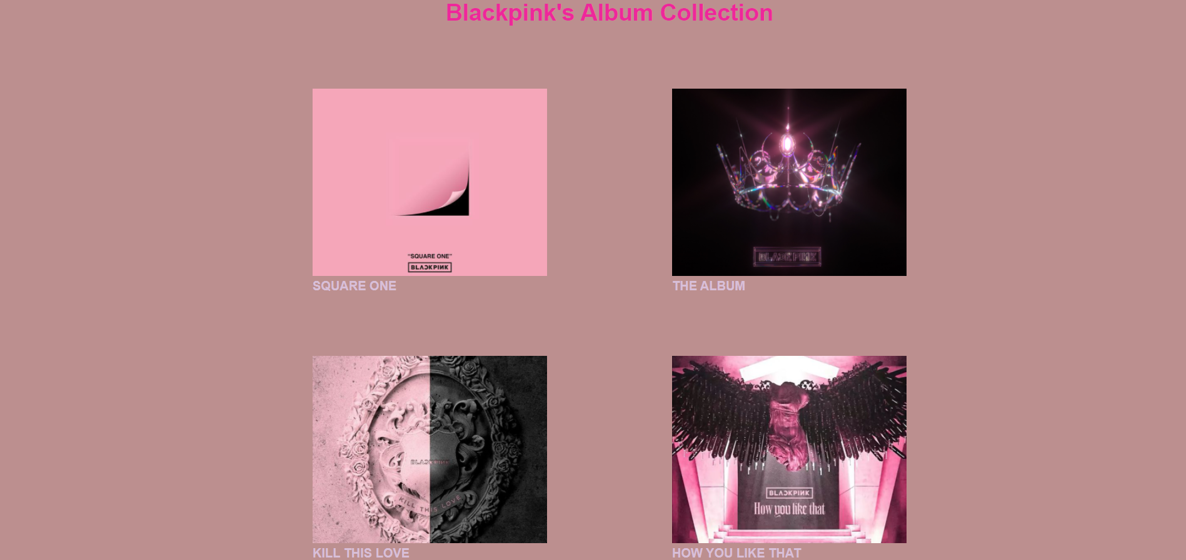

**Menu album ITZY**

